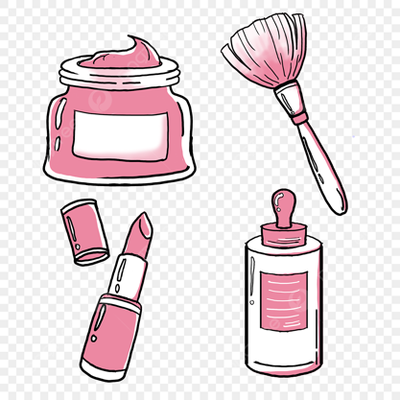

Lifestyle

Fashion

Beauty

The Beauty Bust

The Beauty Bust Vision Board

Top Panel of Clickable Options: Home, About, Content (all articles published from most recent), Beauty, Fashion, Lifestyle, Fitness, etc.